# **Department of Computer Science and Engineering Islamic University of Technology (IUT)** A subsidiary organ of OIC

# **Lab Report 04**

# CSE 4412: Data Communication and Networking Lab

## 

## **Name:** Tahsin Islam **Student ID:** 210042137 **Section:** SWE **Semester:** 4th (Summer) **Academic Year:** 2022-2023

**Date of Submission:** 14/02/2024

### **Title:** Understanding the basics of Inter-VLAN communication using Router, L3 Switch along with basics of Static Routing

### **Objectives**:

1. Implement Inter-VLAN Routing via Router-on-a-Stick.
2. Implement Inter-VLAN Communication with Layer 3 Switch.
3. Demonstrate Static Routing.
4. Ensure Proper Segmentation and Security.
5. Document and Provide Clear Explanations.

### **Task 1:**

**Step 1: Configuring Switches**

At first, I configured 3 VLANs with VLAN IDs 10, 20, and 30 inside the switch and assigned appropriate names. To do this, I have used the following commands:

|  |
| --- |
| Switch> enable  Switch# config t  Switch(config)# vlan 10  Switch(config-vlan)# name student  Switch(config-vlan)# exit  Switch(config)# vlan 20  Switch(config-vlan)# name teacher  Switch(config-vlan)# exit  Switch(config)# vlan 30  Switch(config-vlan)# name admin  Switch(config-vlan)# exit |

Then I configured the Interfaces belonging to each VLAN. For that, I used the following commands:

|  |
| --- |
| Switch(config)# interface fastEthernet 0/2  Switch(config-if)# switchport mode access  Switch(config-if)# switchport access vlan 10  Switch(config-if)# no shutdown  Switch(config-if)# exit  Switch(config)# interface fastEthernet 0/3  Switch(config-if)# switchport mode access  Switch(config-if)# switchport access vlan 20  Switch(config-if)# no shutdown  Switch(config-if)# exit  Switch(config)# interface fastEthernet 0/4  Switch(config-if)# switchport mode access  Switch(config-if)# switchport access vlan 30  Switch(config-if)# no shutdown  Switch(config-if)# exit  Switch(config)# interface fastEthernet 0/1  Switch(config-if)# switchport mode trunk  Switch(config-if)# switchport trunk allowed vlan all  Switch(config-if)# no shutdown  Switch(config-if)# exit |

This way I have configured the interfaces. For Switch2, the commands are exactly same as Switch1. There is a bit of difference in Switch1.

|  |
| --- |
| Switch(config)# interface fastEthernet 0/3  Switch(config-if)# switchport mode access  Switch(config-if)# switchport access vlan 10  Switch(config-if)# no shutdown  Switch(config-if)# exit  Switch(config)# interface fastEthernet 0/4  Switch(config-if)# switchport mode access  Switch(config-if)# switchport access vlan 20  Switch(config-if)# no shutdown  Switch(config-if)# exit  Switch(config)# interface fastEthernet 0/5  Switch(config-if)# switchport mode access  Switch(config-if)# switchport access vlan 30  Switch(config-if)# no shutdown  Switch(config-if)# exit  Switch(config)# interface fastEthernet 0/1  Switch(config-if)# switchport mode trunk  Switch(config-if)# switchport trunk allowed vlan all  Switch(config-if)# no shutdown  Switch(config-if)# exit  Switch(config)# interface fastEthernet 0/2  Switch(config-if)# switchport mode trunk  Switch(config-if)# switchport trunk allowed vlan all  Switch(config-if)# no shutdown  Switch(config-if)# exit |

As Switch5 has 2 trunk connections that’s why the changes in the command.

For Router-on-a-stick, we configured Switch0 with the following:

|  |
| --- |
| Switch(config)# interface fastEthernet 0/5  Switch(config-if)# switchport mode trunk  Switch(config-if)# switchport trunk allowed vlan all  Switch(config-if)# no shutdown  Switch(config-if)# exit |

Here are the screenshots of the three switches:

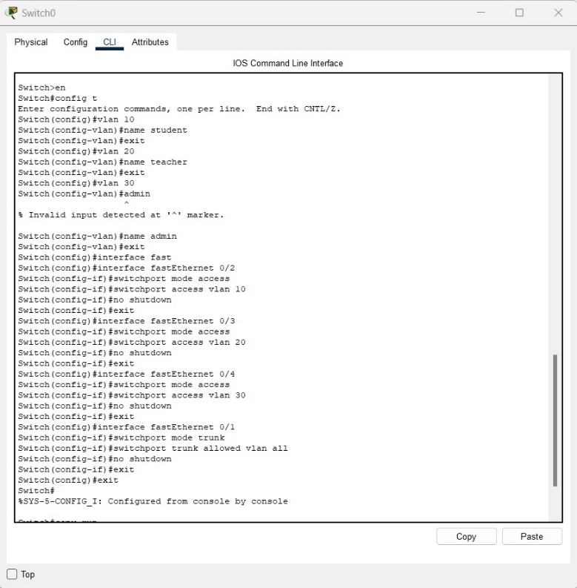

Fig 1.2: Switch0 configuration

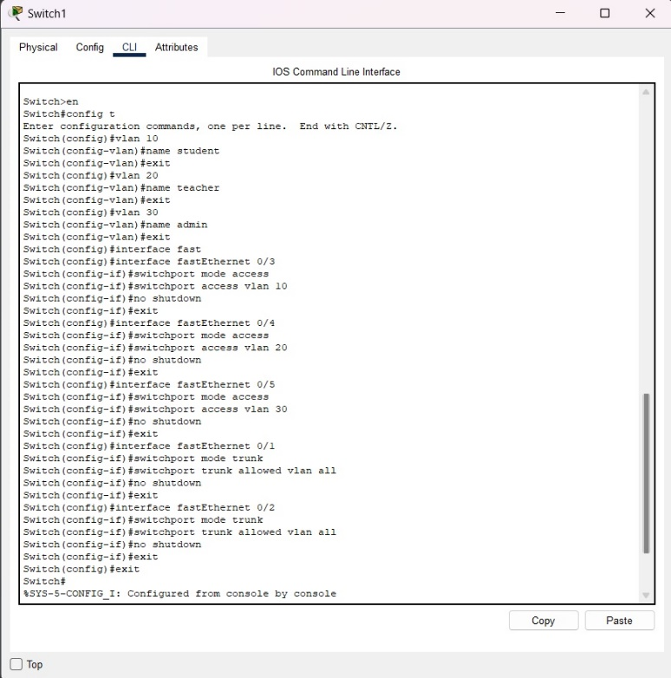

Fig 1.3: Switch1 configuration

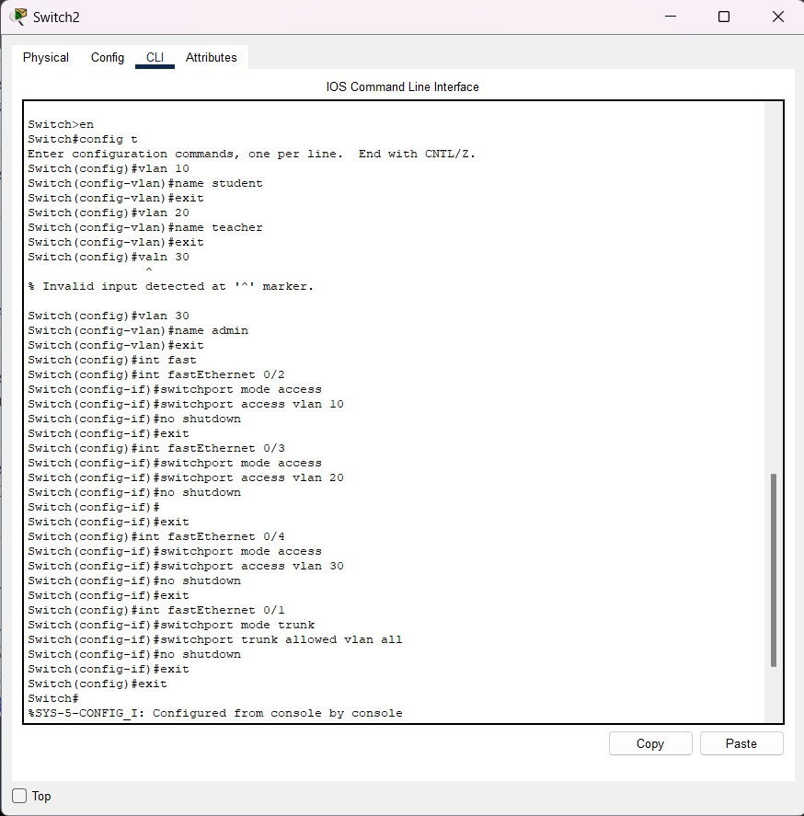

Fig 1.4: Switch3 configuration

**Step 2: Configuring Router**

Now for router configuration, I used the following commands on router’s CLI:

|  |
| --- |
| Router> enable  Router# config t  Router(config)# interface gigabitEthernet 0/0  Router(config-if)#no shutdown  Router(config)#int g0/0.10  Router(config-subif)#encapsulation dot1q 10  Router(config-subif)#ip address 192.168.47.1 255.255.255.0  Router(config-subif)#exit  Router(config)#int g0/0.20  Router(config-subif)#encapsulation dot1q 20  Router(config-subif)#ip address 192.168.57.1 255.255.255.0  Router(config-subif)#exit  Router(config)#int g0/0.20  Router(config-subif)#encapsulation dot1q 20  Router(config-subif)#ip address 192.168.67.1 255.255.255.0  Router(config-subif)#exit |

Here are the screenshots of the router:

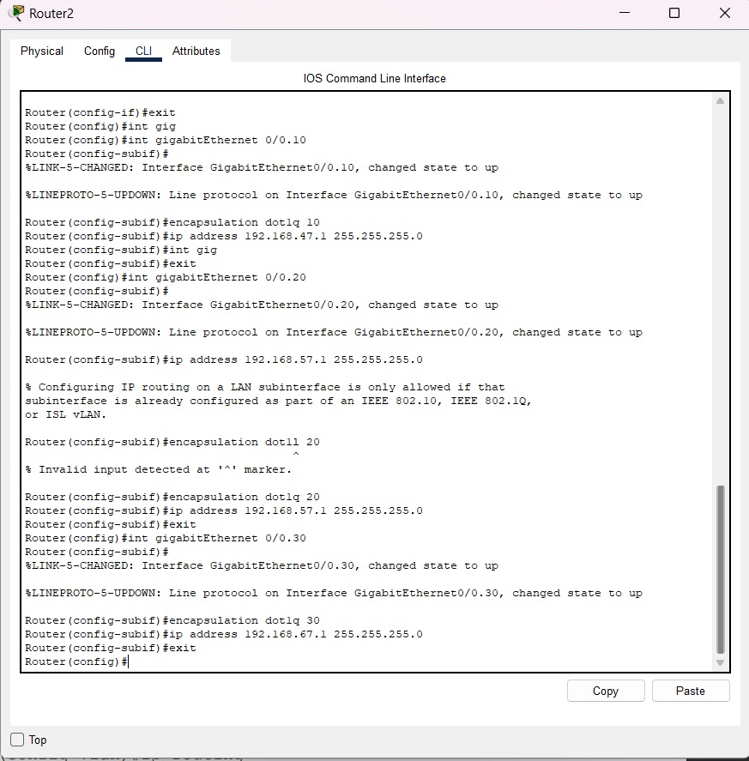

Fig 1.5: Router configuration

**Step 3: Setting Up IPs**

As my ID’s last 2 digits are 37, IP addresses are:

VLAN 10 host’s IP address:

1. PC0: 192.167.47.2
2. PC3: 192.167.47.3
3. PC6: 192.167.47.4

VLAN 20 host’s IP address:

1. PC1: 192.167.57.2
2. PC4: 192.167.47.3
3. PC7: 192.167.47.4

VLAN 30 host’s IP address:

1. PC2: 192.167.67.2
2. PC5: 192.167.67.3
3. PC8: 192.167.67.4

Here are the screenshots:

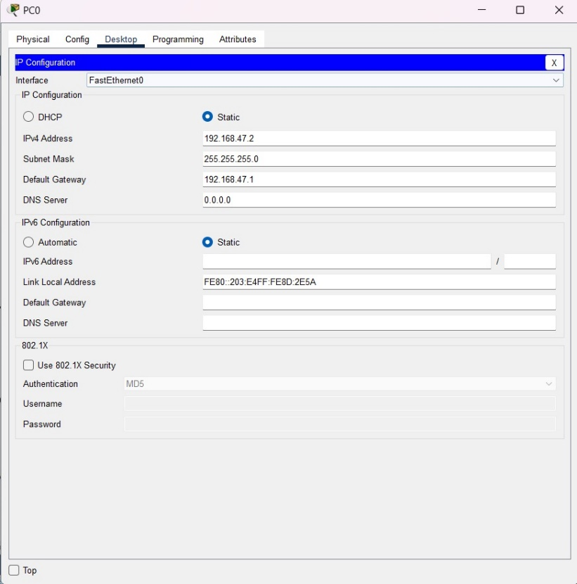

Fig 1.6: IP Address of PC0

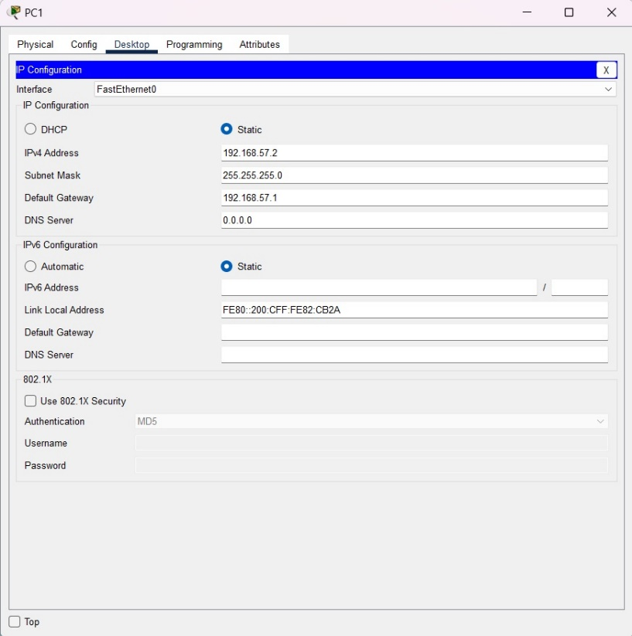

Fig 1.7: IP Address of PC1

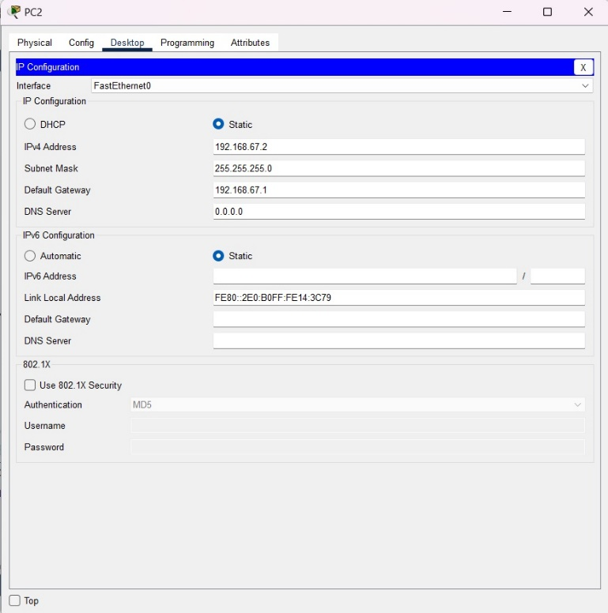

Fig 1.8: IP Address of PC2

**Step 4: Using the ping command from the Terminal**

To ping, I clicked on PC0, went to Desktop, then Command Prompt. In the command prompt, I wrote:

|  |
| --- |
| Ping 192.167.47.3 |

We saw that 4 packets were sent, 4 packets were received, 0 packets were lost as they are on VLAN 10.

But when I sent a ping to PC6 using this:

|  |
| --- |
| Ping 192.167.57.3 |

We saw that, 4 packets were sent, 0 packets were received, 4 packets were lost as they are on different VLANs.

But when I sent a ping to PC1 using this:

|  |
| --- |
| Ping 192.167.57.2 |

We saw that, 4 packets were sent, 4 packets were received, 0 packets were lost as they are under same switch.

Here is the screenshot of the command prompt of PC0:

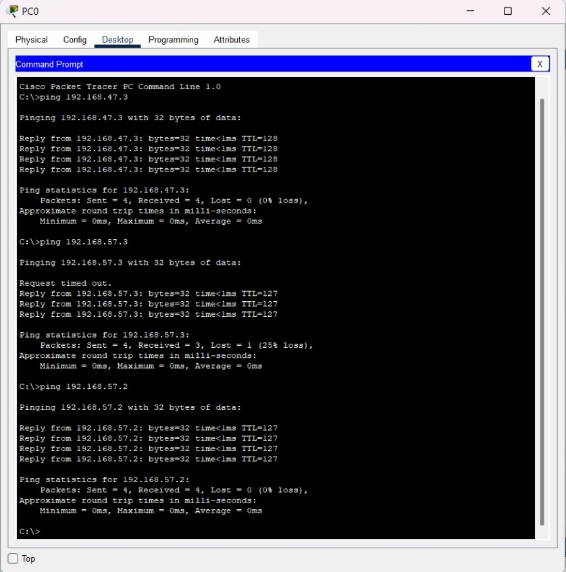

Fig 1.9: Command Prompt of PC0

### **Task 2:**

**Step 1: Configuring Switches**

At first, I configured 4 VLANs with VLAN IDs 10, 20, 30, and 40 inside the switch and assigned appropriate names. To do this, I have used the following commands:

|  |
| --- |
| Switch> enable  Switch# config t  Switch(config)# vlan 10  Switch(config-vlan)# exit  Switch(config)# vlan 20  Switch(config-vlan)# exit  Switch(config)# vlan 30  Switch(config-vlan)# exit  Switch(config)# vlan 40  Switch(config-vlan)# exit |

Then I configured the Interfaces belonging to each VLAN. For that, I used the following commands:

|  |
| --- |
| Switch(config)# interface fastEthernet 0/3  Switch(config-if)# switchport mode access  Switch(config-if)# switchport access vlan 10  Switch(config-if)# no shutdown  Switch(config-if)# exit  Switch(config)# interface fastEthernet 0/4  Switch(config-if)# switchport mode access  Switch(config-if)# switchport access vlan 20  Switch(config-if)# no shutdown  Switch(config-if)# exit  Switch(config)# interface fastEthernet 0/5  Switch(config-if)# switchport mode access  Switch(config-if)# switchport access vlan 30  Switch(config-if)# no shutdown  Switch(config-if)# exit  Switch(config)# interface fastEthernet 0/6  Switch(config-if)# switchport mode access  Switch(config-if)# switchport access vlan 40  Switch(config-if)# no shutdown  Switch(config-if)# exit  Switch(config)# interface fastEthernet 0/2  Switch(config-if)# switchport mode trunk  Switch(config-if)# switchport trunk allowed vlan all  Switch(config-if)# no shutdown  Switch(config-if)# exit  Switch(config)# interface fastEthernet 0/1  Switch(config-if)# switchport mode trunk  Switch(config-if)# switchport trunk allowed vlan all  Switch(config-if)# no shutdown  Switch(config-if)# exit |

This way I have configured the interfaces. For Switch1, the commands are exactly same as Switch0. The screen shots are given below:

**Step 2: Configuring Multilayer Switch**

Now for router configuration, I used the following commands on router’s CLI:

|  |
| --- |
| Switch> enable  Switch# config t  Switch(config)# vlan 10  Switch(config-vlan)# exit  Switch(config)# vlan 20  Switch(config-vlan)# exit  Switch(config)# vlan 30  Switch(config-vlan)# exit  Switch(config)# vlan 40  Switch(config-vlan)#ip routing  Switch(config)#int range fa0/1-2  Switch(config-if-range)#switchport trunk encapsulation dot1q  Switch(config-if-range)#switchport mode trunk  Switch(config-if-range)#no shutdown  Switch(config-if-range)#int vlan 10  Switch(config-if)#ip address 192.168.48.1 255.255.255.0  Switch(config-if)#no shut  Switch(config-if)#exit  Switch(config-if-range)#int vlan 20  Switch(config-if)#ip address 192.168.49.1 255.255.255.0  Switch(config-if)#no shut  Switch(config-if)#exit  Switch(config-if-range)#int vlan 30  Switch(config-if)#ip address 192.168.50.1 255.255.255.0  Switch(config-if)#no shut  Switch(config-if)#exit  Switch(config-if-range)#int vlan 40  Switch(config-if)#ip address 192.168.51.1 255.255.255.0  Switch(config-if)#no shut  Switch(config-if)#exit |

Here are the screenshots of the switch:

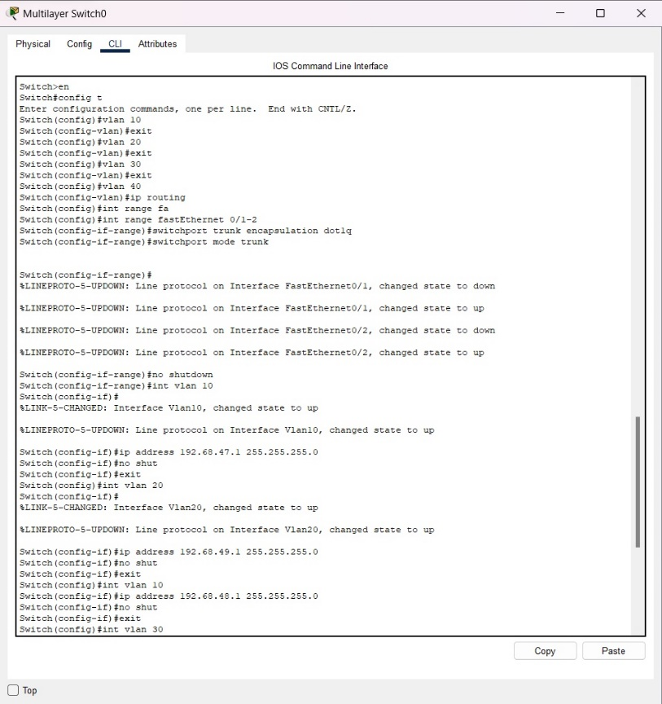

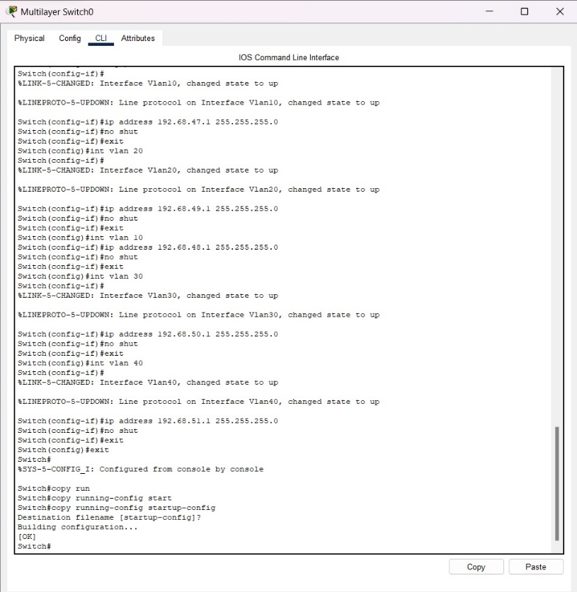

**Step 3: Setting Up IPs**

As my ID’s last 2 digits are 37, IP addresses are:

VLAN 10 host’s IP address:

1. PC0: 192.167.48.2
2. PC4: 192.167.48.3

VLAN 20 host’s IP address:

1. PC2: 192.167.49.2
2. PC5: 192.167.49.3

VLAN 30 host’s IP address:

1. PC2: 192.167.50.2
2. PC5: 192.167.50.3

VLAN 40 host’s IP address:

1. PC2: 192.167.51.2
2. PC5: 192.167.51.3

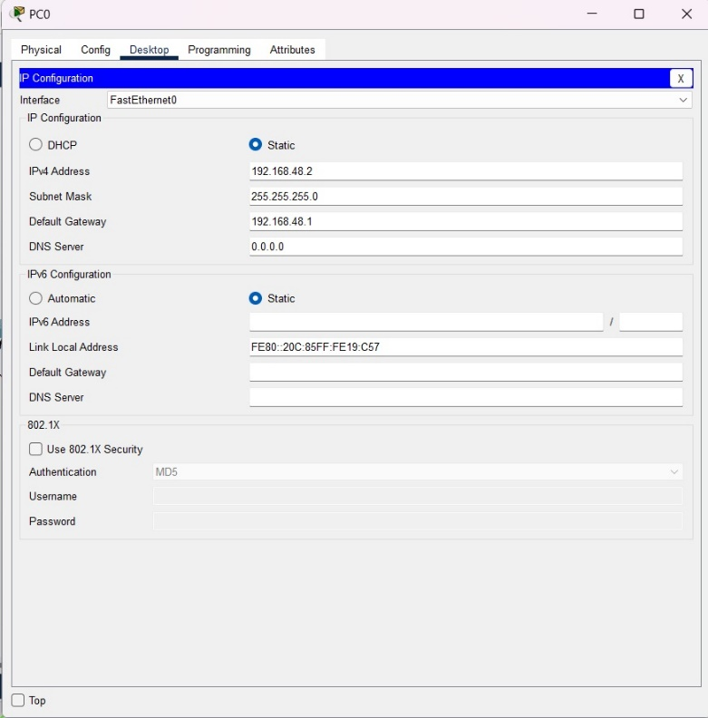

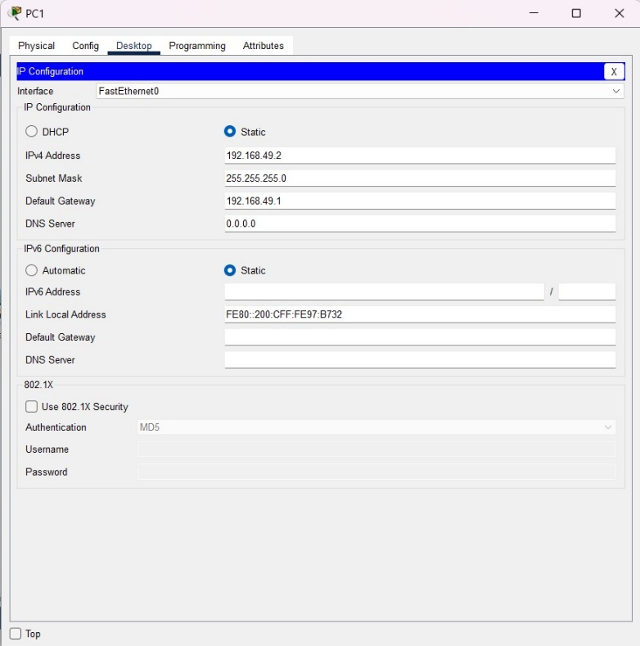

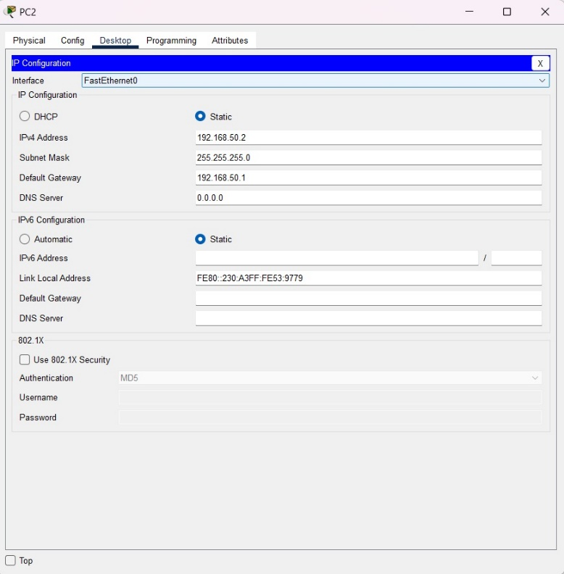

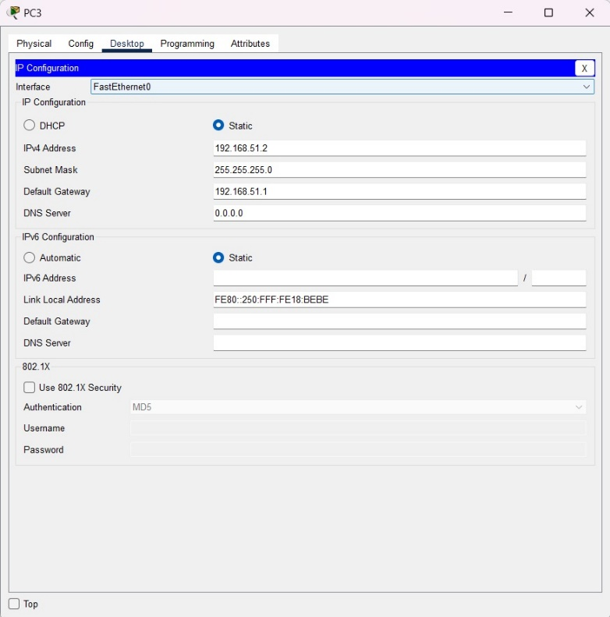

**Step 4: Using the ping command from the Terminal**

To ping, I clicked on PC0, went to Desktop, then Command Prompt. In the command prompt, I wrote:

|  |
| --- |
| Ping 192.167.48.3 |

We saw that 4 packets were sent, 4 packets were received, 0 packets were lost as they are on VLAN 10.

But when I sent a ping to PC6 using this:

|  |
| --- |
| Ping 192.167.49.3 |

We saw that, 4 packets were sent, 0 packets were received, 4 packets were lost as they are on different VLANs.

But when I sent a ping to PC1 using this:

|  |
| --- |
| Ping 192.167.49.2 |

We saw that, 4 packets were sent, 4 packets were received, 0 packets were lost as they are under same switch.

### **Task 3:**

### **Questions (Answer to the point)**:

* + - 1. Why do we need L3 Switches?

**Ans:** L3 switches are needed to perform routing functions at the network layer (Layer 3) of the OSI model.

* + - 1. What is the use router in Inter-Vlan Routing?

**Ans:** Routers are used in Inter-VLAN Routing to facilitate communication between different VLANs. They route traffic between VLANs, allowing devices in different VLANs to communicate with each other.

* + - 1. What changes are needed while configuring VLANs using L3 switches instead of Router-on-a-stick approach?

**Ans:** When configuring VLANs using L3 switches instead of the Router-on-a-stick approach, changes involve configuring VLAN interfaces directly on the switch and enabling routing between them. This eliminates the need for a separate router interface for each VLAN and allows for faster inter-VLAN communication within the switch itself.

* + - 1. What is next-hop floating address?

**Ans:** A next-hop floating address is a backup route used in routing protocols such as OSPF or EIGRP. It is configured with a higher administrative distance than the primary route and is used only if the primary route becomes unavailable.

* + - 1. What is the disadvantage of static routing?

**Ans:** A disadvantage of static routing is its lack of flexibility and scalability. Static routes require manual configuration and do not adapt to changes in the network topology automatically. This makes them less suitable for large or dynamic networks where routing needs may change frequently.

### **Challenges (if any):**

No challenges faced